**Question:**

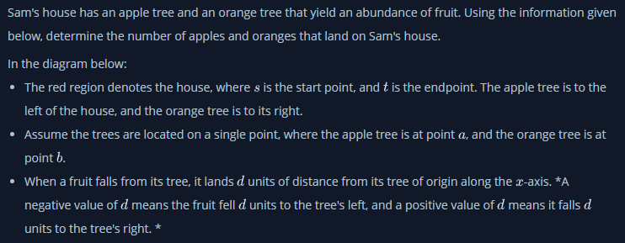



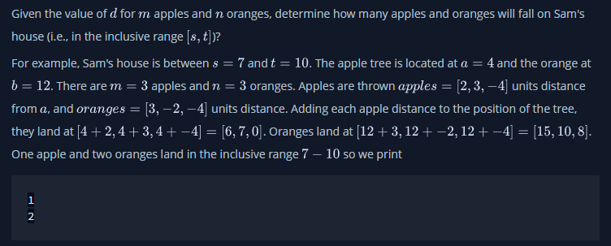

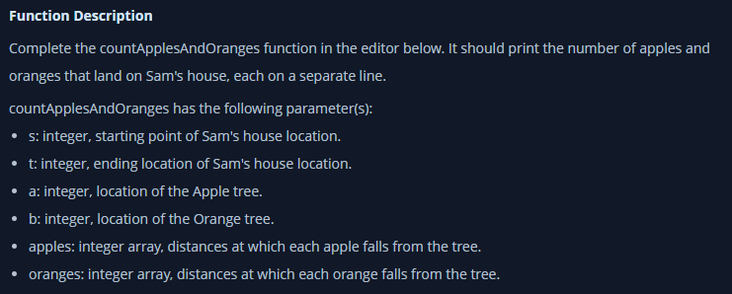

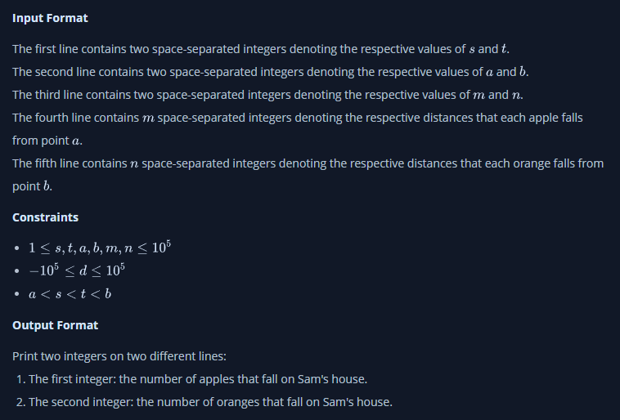

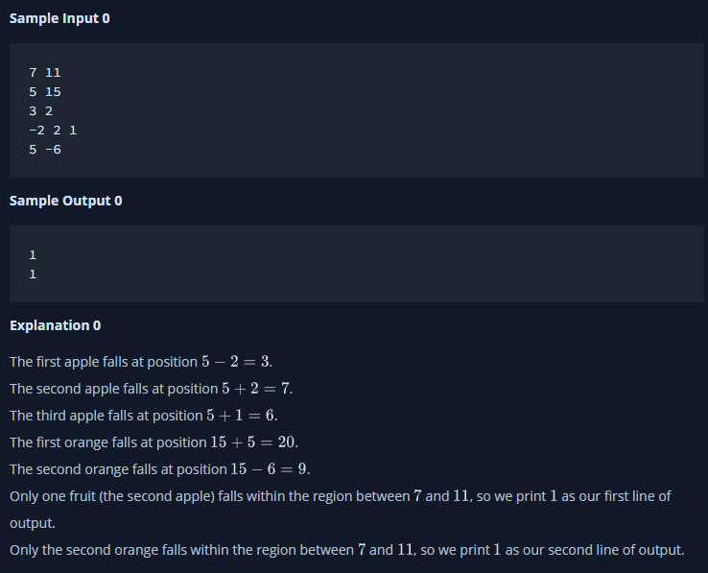

We just do basic math of number line here.

**Answer:**

**def** countApplesAndOranges(s, t, a, b, apples, oranges):

    applecount = 0

    orangecount = 0

**for** i **in** apples:

**if** a+i>=s **and** a+i<=t:

            applecount += 1

**for** i **in** oranges:

**if** b+i>=s **and** b+i<=t:

            orangecount += 1

**print**(applecount)

**print**(orangecount)

**if** **__name__** == '__main__':

    first_multiple_input = **input**().rstrip().split()

    s = **int**(first_multiple_input[0])

    t = **int**(first_multiple_input[1])

    second_multiple_input = **input**().rstrip().split()

    a = **int**(second_multiple_input[0])

    b = **int**(second_multiple_input[1])

    third_multiple_input = **input**().rstrip().split()

    m = **int**(third_multiple_input[0])

    n = **int**(third_multiple_input[1])

    apples = **list**(**map**(**int**, **input**().rstrip().split()))

    oranges = **list**(**map**(**int**, **input**().rstrip().split()))

    countApplesAndOranges(s, t, a, b, apples, oranges)